**Part1**

Create a script that will loop through one year of stock data for each run and return the total volume each stock had over that year.

You will also need to display the ticker symbol to coincide with the total stock volume.

***Year 2016***

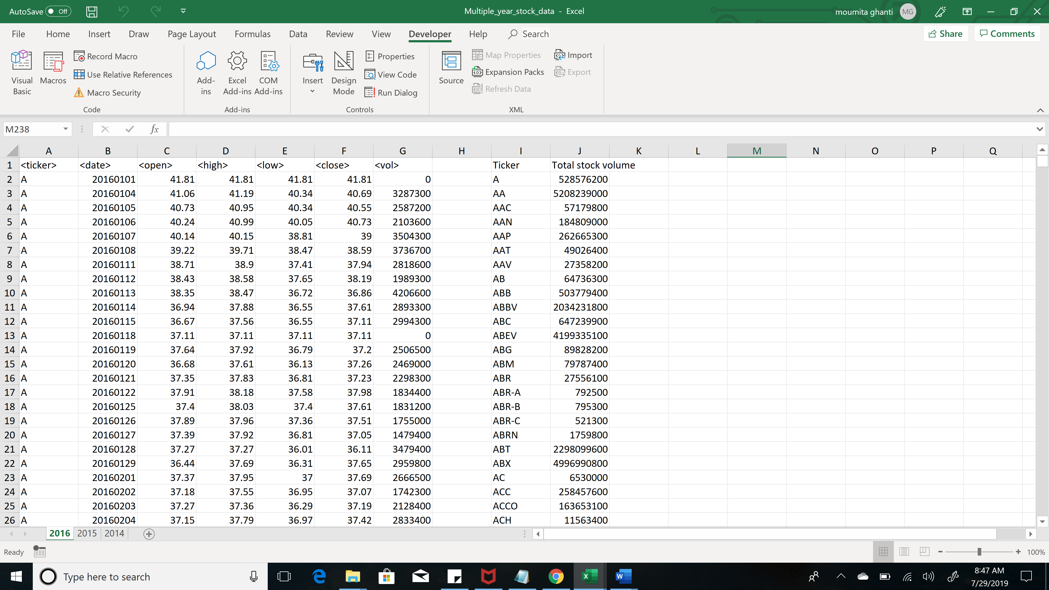

***Year 2015***

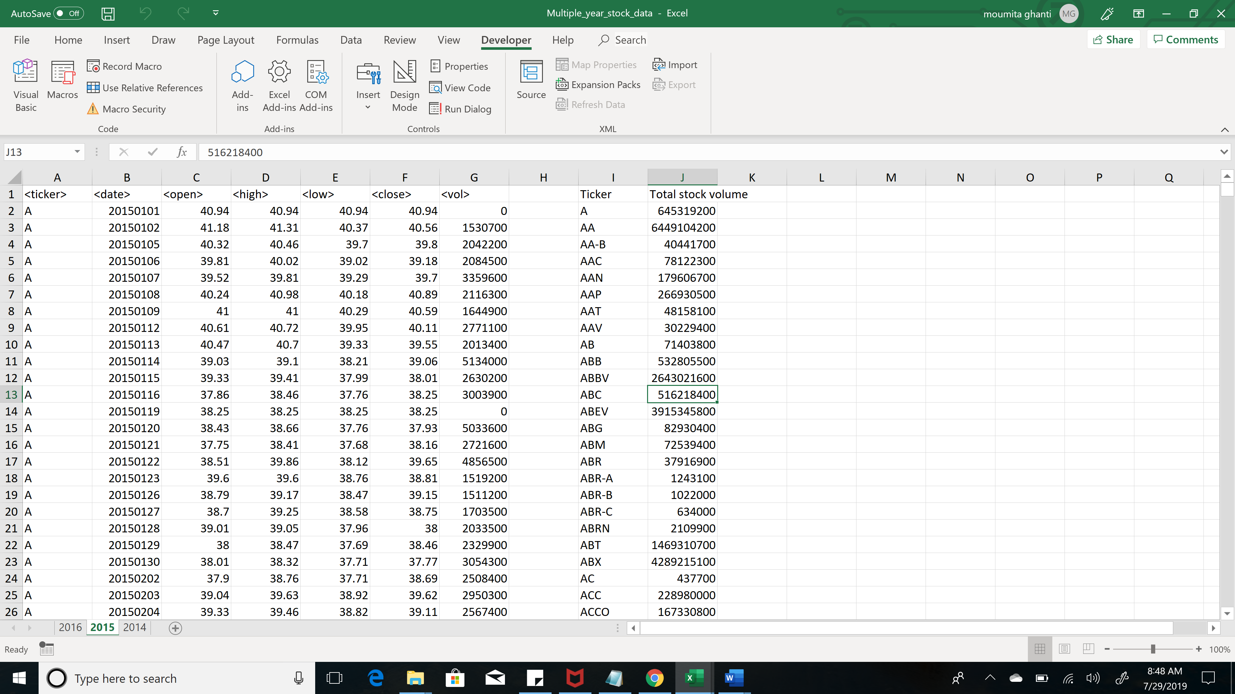

***Year 2014***

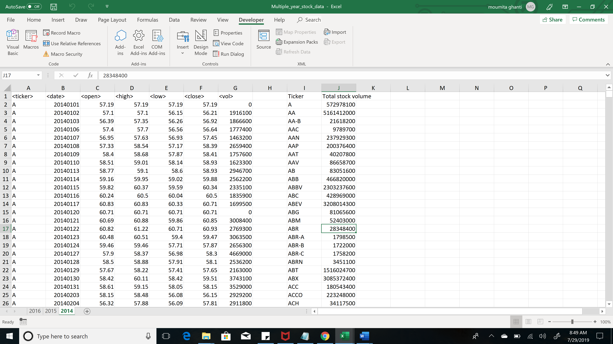

**Part2**

Create a script that will loop through all the stocks for one year for each run and take the following information.

The ticker symbol.

Yearly change from opening price at the beginning of a given year to the closing price at the end of that year.

The percent change from opening price at the beginning of a given year to the closing price at the end of that year.

The total stock volume of the stock.

You should also have conditional formatting that will highlight positive change in green and negative change in red.

***Year 2016***

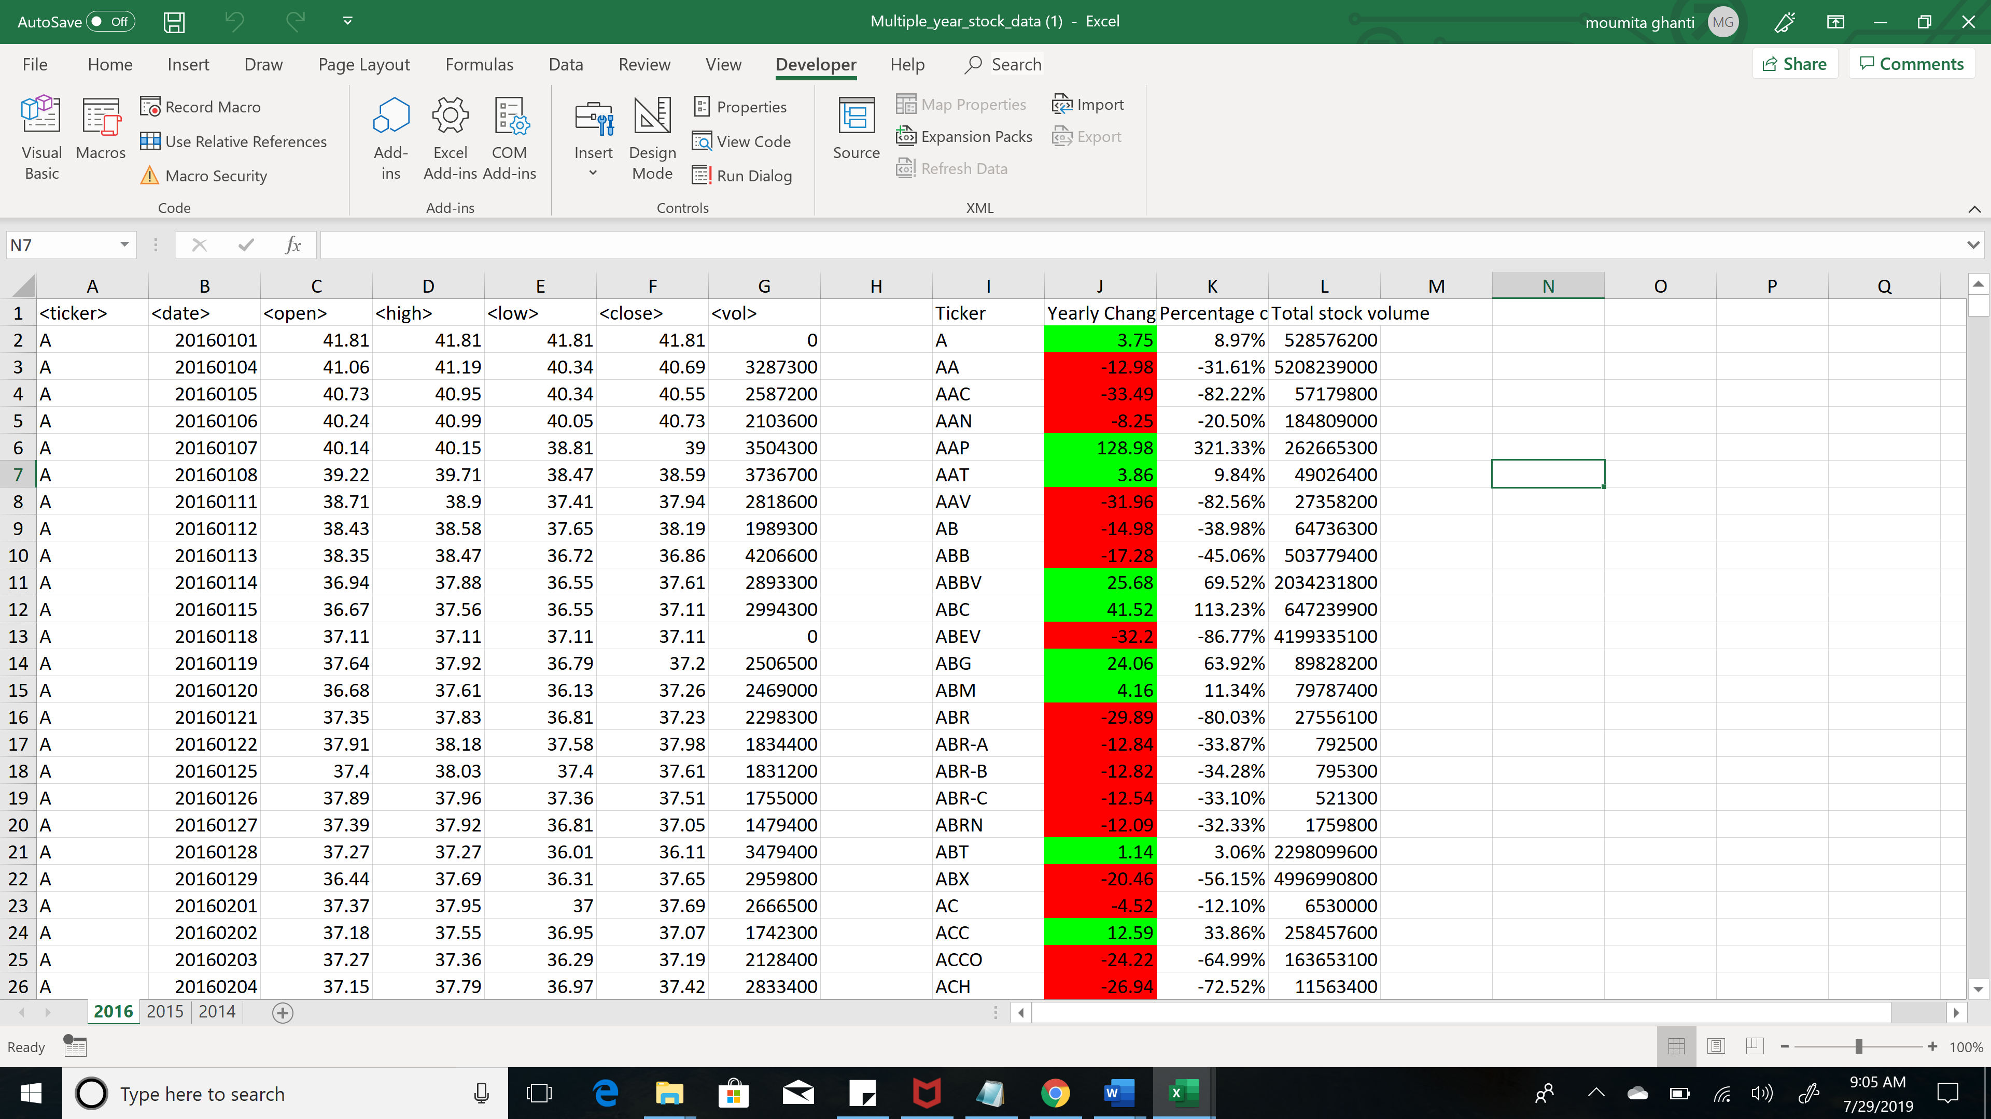

***Year 2015***

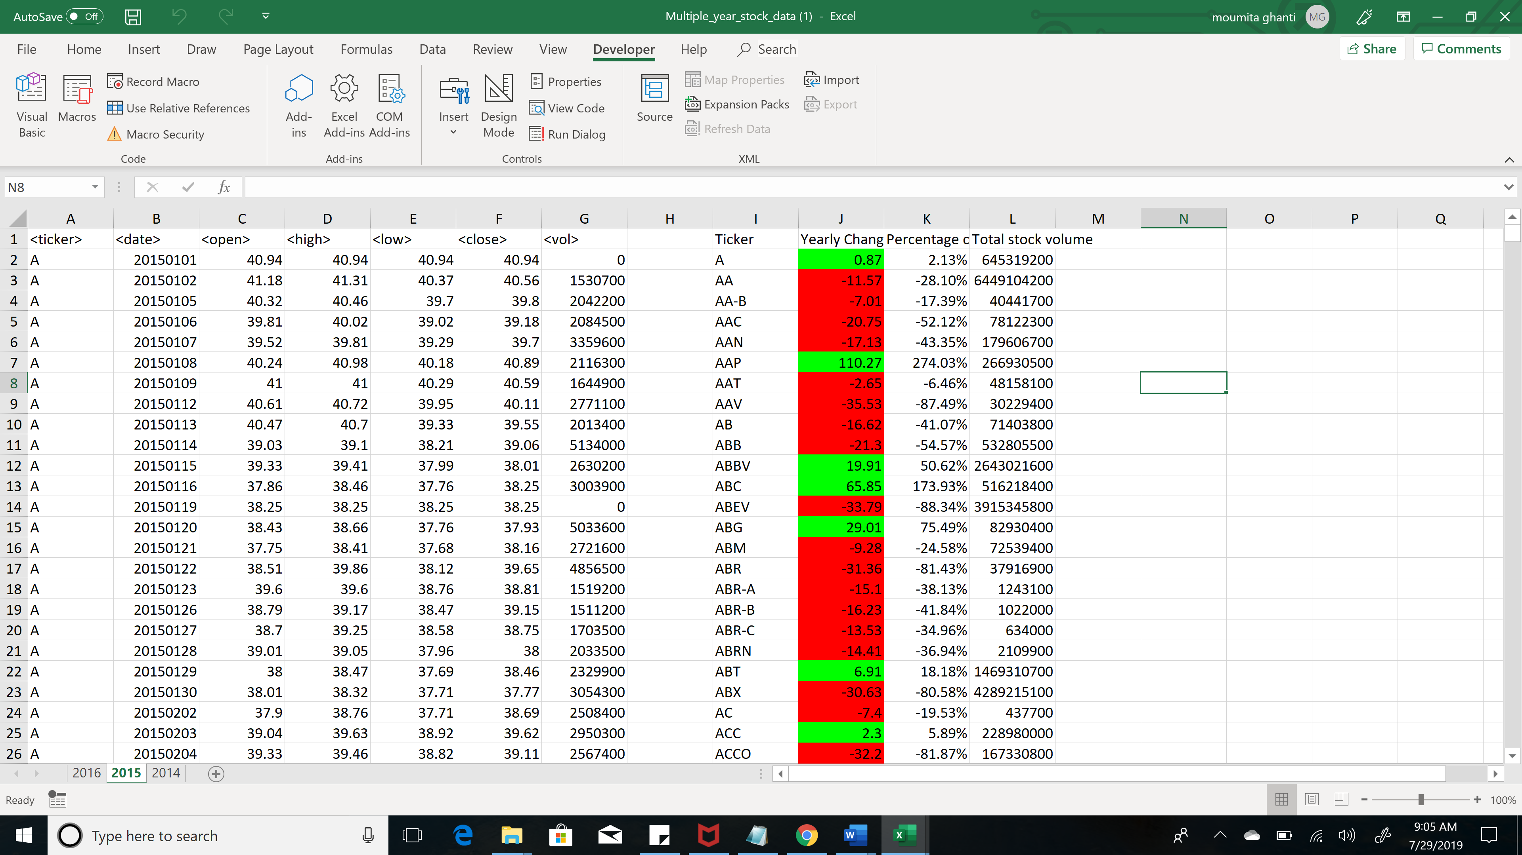

***Year 2014***

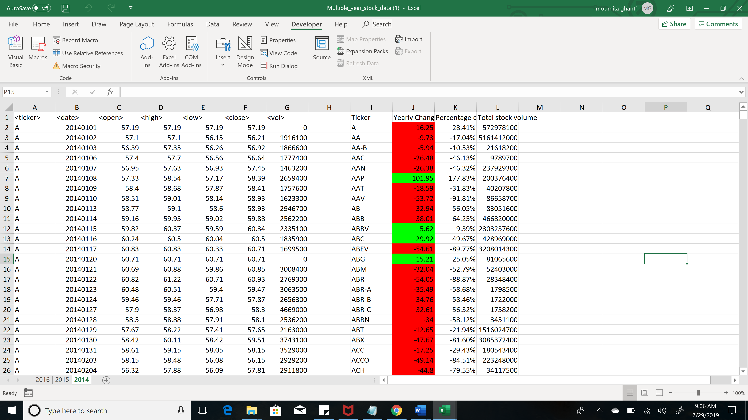

**Part3**

our solution will include everything from the moderate challenge.

Your solution will also be able to return the stock with the "Greatest % increase", "Greatest % Decrease" and "Greatest total volume".

***Year 2016***

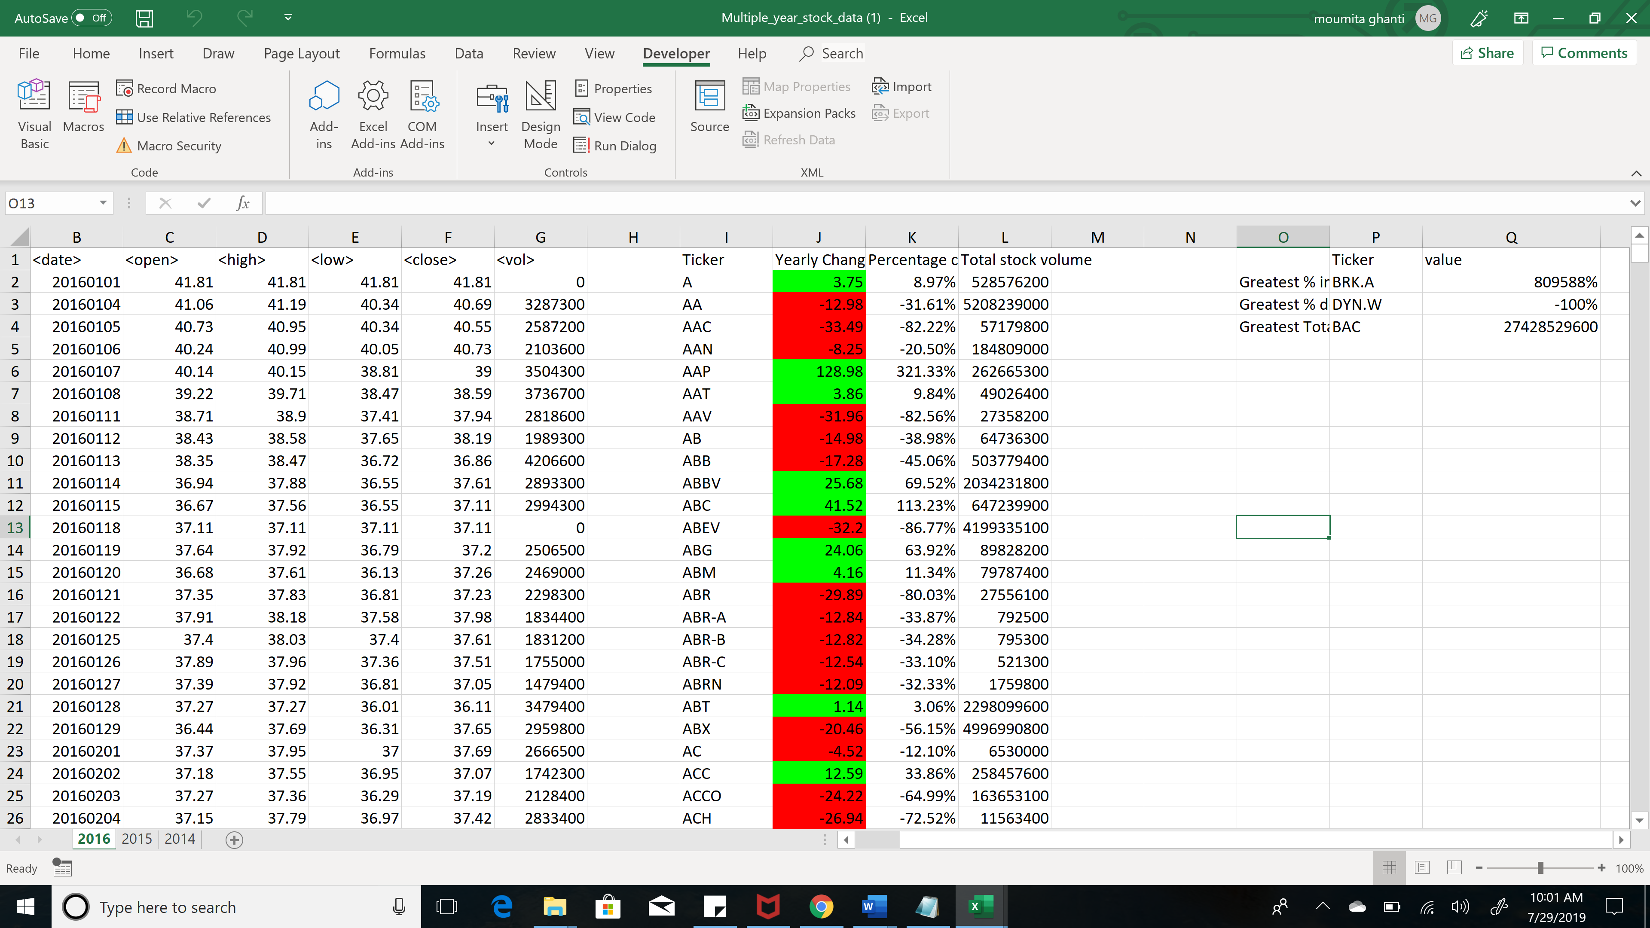

***Year 2015***

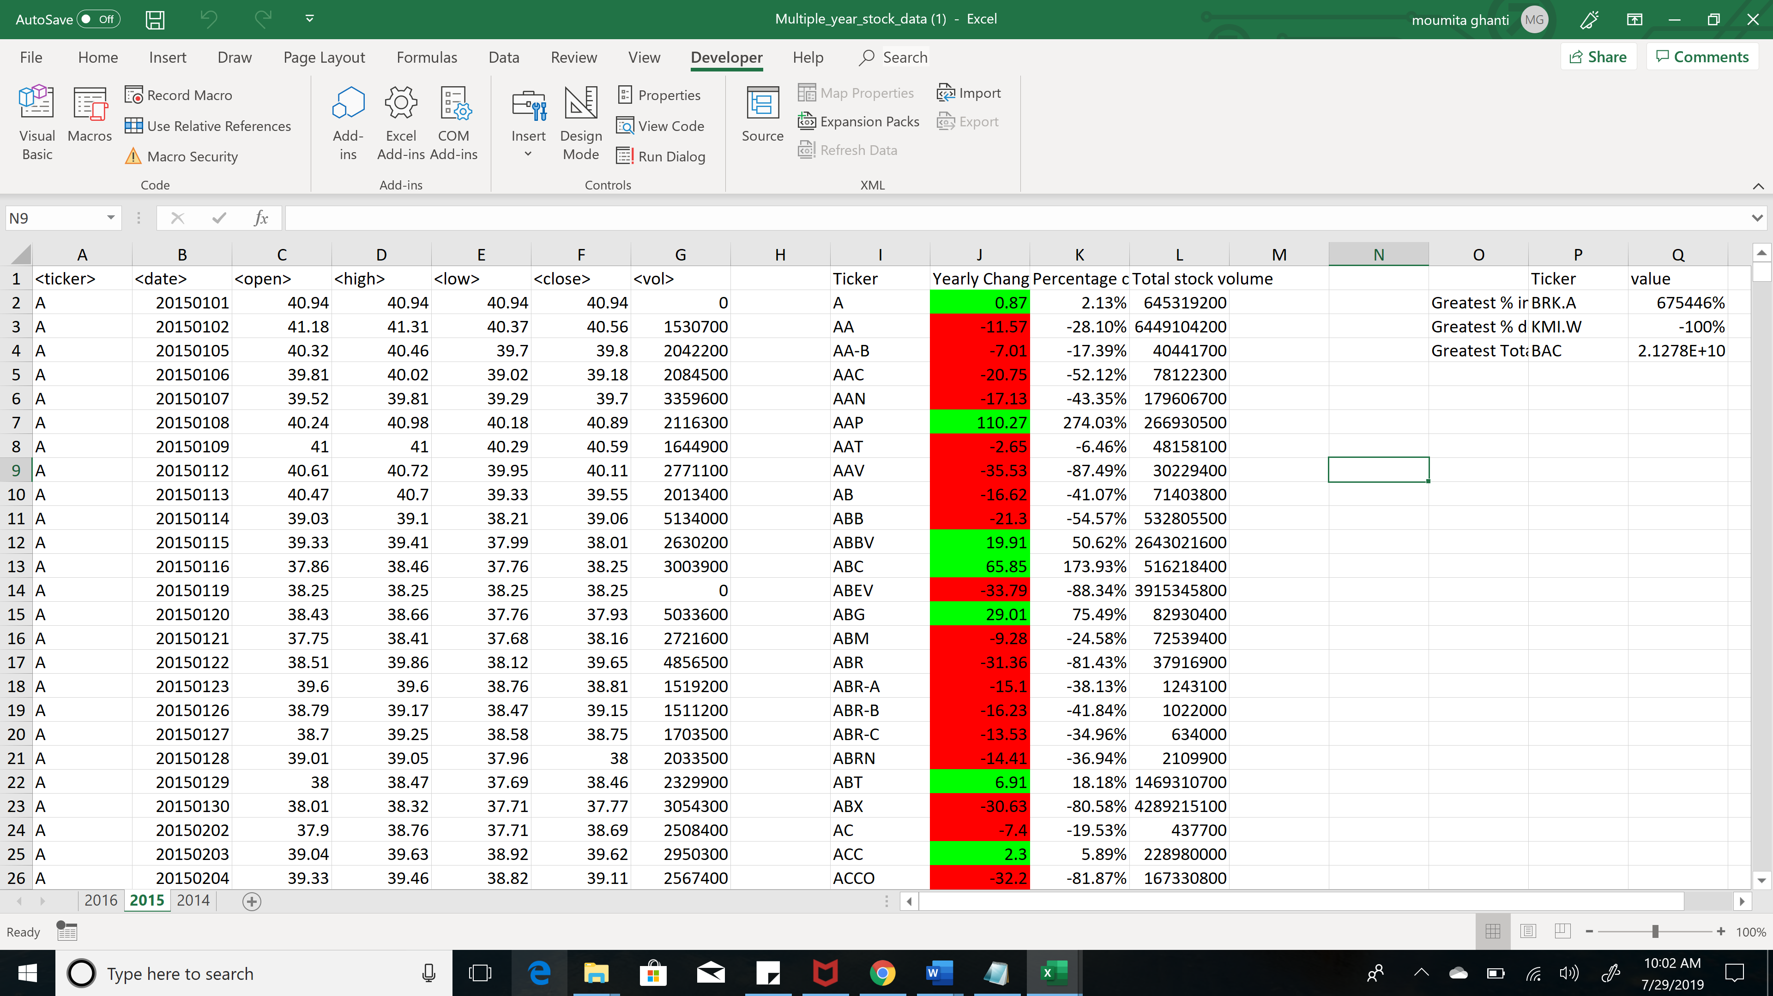

***Year 2014***

